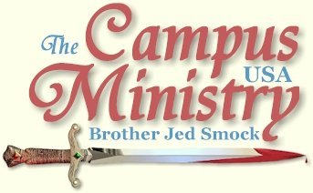
brojed.org
brojed@aol.com
573-999-0347
Youtube Account: brotherjedCMUSA

Check out our Youtube account...Martha Has Posted Some New Videos
Also, Go to our web site to check out Bro. Jed's current schedule
or to make a donation! Thanks!
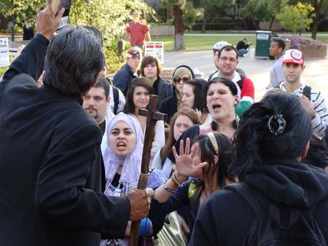

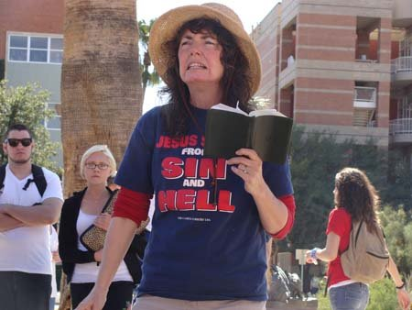

DESPITE THE WEATHER

Arizona State University, February 22, 2010

It was raining and cold (for Arizona) today and our host John G. thought that Arizona students, who are not used to the rain, would not stop and listen. At 1 PM I received a cell phone call from one the members of the Secular and Free Thought Society, who asked if we were coming to campus. Since the rain had stopped, I told him that we would be there within the hour.

The atheists were waiting for us. However, we did not get a good class break until about 3 PM. Both Cindy and I were feeling weak in the flesh. She has a cold and I was tired. However, I did muster the strength the gather a crowd of 25-35 students. Many of them were from the SFTS, who had made handmade signs promoting atheism. Several of them stood on the wall as I preached. They enthusiastically promoted their unbelief to the shame of most Christians, who lack enthusiasm for spreading the faith.

Thomas, a grey haired fellow, on a bike defended the preaching to the atheists. One of whom was shouting slogans concerning Scientology. He also witnessed with me to a girl who had one parent who was a Muslim and a professing Christian, who accused me of giving Christianity a bad name. The girl who has the Muslim connection was respectful and open, even though I had made an example of her earlier for smoking. Thomas has been forced into retirement by the economy. I appreciated his maturity in the faith.
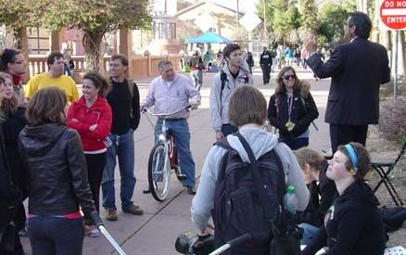
Thomas, who stood with us all week is on the bicycle...Members of the Secular Free Thought Society are on the front right.

At one point it started raining again, but that did not deter the student s from listening. Cindy gained strength in the spirit to take a turn at preaching.

The President of the SFTS invited me to address their club tomorrow indoors at 2:30. Cindy and John G. will continue the outdoor meeting. Cindy went inside to escape the cold about 4:45. I preached for 15 more minutes and told the students we would continue tomorrow. When I went inside to find Cindy, I was approached by a virgin who had painted her arms. Then a few others gathered around until 5:30.

Cindy and I were pleased about the results because earlier we suspected that the day would be a washout. Cindy was also able to have a good conversation with Tracy M., who along with, Len, the man she was to marry were editors of the Free Press, the student paper. Tracy wrote a favorable article about me back in the mid-eighties, which was published in Who Will Rise Up? She is now working on her PhD. and has eight children. Len is a lawyer and political science professor. They are long time friends of the ministry.

MARTHA AND PRISSY FACE DOWN LEWD GAY BLADES

Arizona State University, February 23, 2010,

They had a religious fair on campus with the Lutherans, Catholics, Mormons, Quakers, 7th Day Adventists, Jews, and Moslems manning tables in front of Danforth Chapel. They were giving out bottled water and pizza, which is about all the fair was worth. They were playing amplified contemporary Christians music which was evidently placid enough not to offend the Jews and Moslems. As for me I did not even know that it was Christian music until Cindy informed me later. The loud music made it difficult to preach until 1 PM when the fair and music officially shut down. After this Cindy attracted a large crowd by reminding the students when Jesus returns he will not be giving cold water and pizza. But he will return in flaming fire to judge the world in righteousness and destroy his enemies.

Religious Groups on Campus Passed Out Free Pizza and Water

When I took my turn preaching, one middle aged fellow from the Lutheran booth started promoting free brownies at the top of his voice. It disturbed me that he had such a strong voice with which he could have preached, but instead he used it to promote brownies. He might as well have been with the girl scouts, who were selling their cookies on campus today. One boy, who professed to be a Christian, was planning on being a youth pastor; however, he admitted that he masturbated, looked at pornography and was doing things with his girl friend. He thought that was all covered by the grace of God.

At 2:30 Martha, Priscilla and I went into the Science Building where the Secular and Free Thought Society had their club meeting. I quoted from the Divine Comedy when Dante, following Virgil, arrived at the gates of Hell where were inscribed these dreadful words: "To rear me was the task of Power divine, Supremest Wisdom, and primeval Love. . . Abandon all hope ye who enter here.” I explained how Hell is a testimony to the power, wisdom and love of God. I spoke for 20 minutes then had 10 more minutes for Q&A.
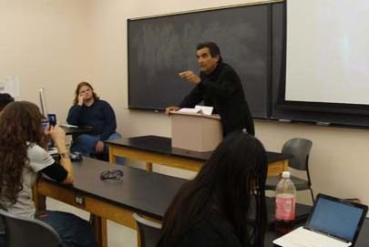

Brother Jed Addresses the Secular Free Thought Society
http://www.youtube.com/watch?v=FfFJOmvPudc

A professor from a community college spoke on different world views emphasizing what he called historical Christianity which was basically Augustinianism/Calvinism with God existing outside of time. During the Q&A, I had the opportunity to expound on Open Theism and free will. It was a productive 90 minute session of thoughtful discussion concerning the nature of God, probably, much more thoughtful then most Christian Bible studies and church services. I have been invited to speak to the group again on Thursday night.

Meanwhile, Martha received a text message that the battle was raging outside with Sister Cindy and John G. prevailing against the gates of Hell. John wore a sweat shirt which said “God is a Capitalist.”
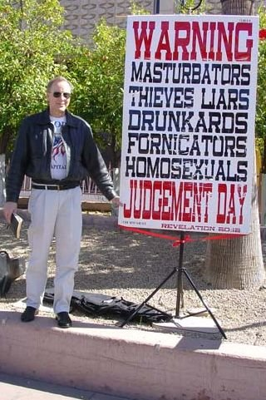
Bro. John and his Banner

Cindy called upon me when I returned to the outside warfare. There was a vulgar lesbian with a male sounding voice who exposed herself to me. I looked away without seeing anything but most in the crowd saw a lot and the reaction of the crowd told me there was a lot to see.
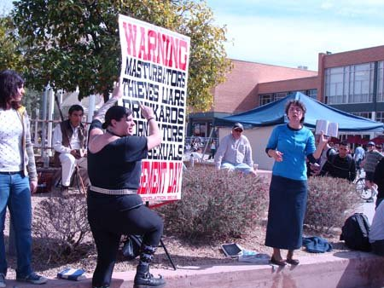
Lesbian is NOT Happy About the Banner
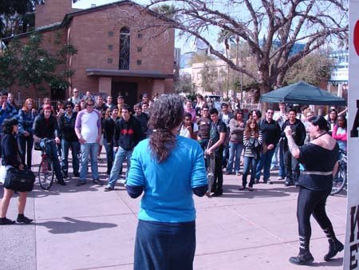
Sister Cindy and Diana the Lesbian (far right)

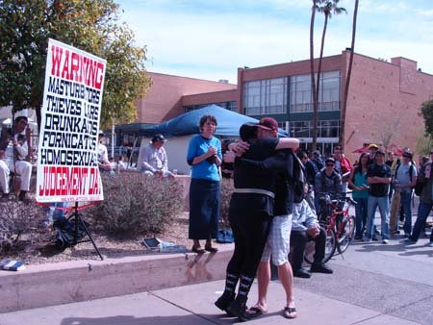
Lesbian Diana Giving Free Hugs

Two gay blades were sitting in the front of the crowd, whose favorite expression was a vulgar reference to mothers. At one point they accused Martha and Priscilla of lusting after their “b.a.” Martha exploded and got into their face and rebuked them for comments concerning ugly remarks they were saying about her mother. The gay blades jumped out of their chair and called Martha, “a stupid white girl.” Martha was facing down these perverts rebuking and reproving them. Martha finally told them where to go. That is, if they were determined to sin, they were choosing Hell. In other words Martha was implying “Live with your choices, perverts.” Priscilla was backing up Martha. Cindy was taking pictures and I was enjoying watching the girls do battle, proud of their stand. Of course, most of the crowd, including the professing Christians, sided with the gay blades.

Afterwards, I had a conflict with some Muslim females who were quite stirred especially after I called Mohammad a terrorist and more so after I read a passage from the Koran which teaches that Muslim men can beat (lightly) their wives.

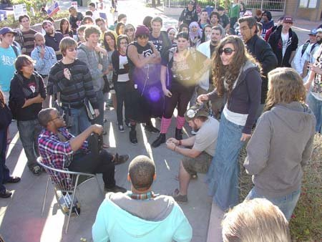
Martha Confronts the Sodomites

He Stands Up on a Chair to Get in Martha's Face

Priscilla Stands With Martha...While One Sodomite Yells Hysterically, the Other shows His Bottom

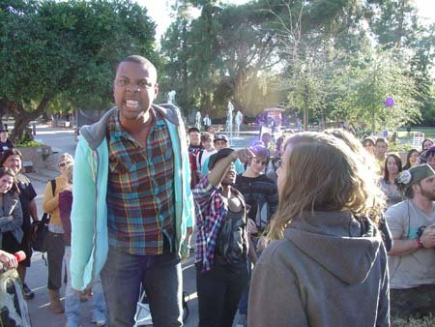
This Gives Us a Little Idea of what Lot Had to Deal With

Cindy finished the day by mostly just reading from John 3, Romans 1 and other passages of the Bible. They were yelling and screaming against the Bible reading. We left campus at 6 PM after a very exciting day.

This evening I received the following email which reminds me that there are usually those in the crowd who are supportive.

“Brother Jed,
I happened to witness some of your preaching today over by the MU @ ASU with some of my friends! I admire your boldness and willingness to get up and speak to a generation that denies God, desires for evil and ultimately despises its Creator.”

LORD, SMITE THE MUSLIM JIHADISTS

Arizona State University, February 24, 2010

Today I read from the Unholy Koran demonstrating how the religion of Violence is an attack on the Gospel of Jesus Christ because it denies that Jesus died on the Cross and denies the Resurrection, claiming that Jesus was taken into heaven body and soul without death. The Koran clearly teaches that God has no Son. There were Christians in Arabia in the 7th Century; Mohammad would have had opportunities to hear the gospel but he rejected it. Mohammad was a liar and a terrorist.

I was holding the Koran in one hand and my crucifix staff in the other. Moslems hate the Cross. Their unholy book teaches that when Jesus returns he will destroy all crosses. Suddenly a veiled Muslim female grabbed the Koran out of my hand and ran off with it. Cindy and Dr. Nan chased after her, but some of her Muslim cohorts surrounded her. The Muslims lied claiming that I hit the thief with my staff. Many in the crowd started spreading this lie. Soon Muslims were coming from all over and advancing on me in a threatening manner.

Later I was informed that two Muslims which were behind me wrapped their scarves around their faces and were preparing to attack me. John G. gave them the evil eye. They knew they were being watched so they evidently changed their mind (at least for the time being) about jumping me. One irate Muslim threatened Martha and tried to move against her. But a few level headed Muslim females restrained him. The lesbians to whom Martha was witnessing sided with Martha and got between her and the mad Muslim. At one point Martha and Cindy got beside me to watch my back. Then the mad Muslim lunged toward me and Martha stuck out her arm to deflect his attack. My daughters all have the fearless warrior spirit of Deborah. As you know Evangeline is a trained warrior in the US Army. When Evangeline gets out of the army she has promised to take a mission trip with me. The main job of a Chaplain Assistant is to protect the Chaplains. I am ordained of God to be a chaplain to college students. I will look forward to the retired Chaplain’s Assistant, Evangeline, to protect this Chaplain :). It’s OK many of those who oppose me are either women or men who have been feminized. She should be able to handle them without a problem.

One of the AngryMuslim Girls
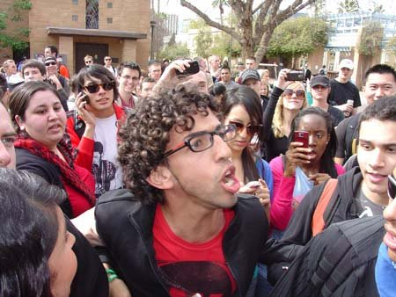
This Muslim Kept Charging Bro. Jed
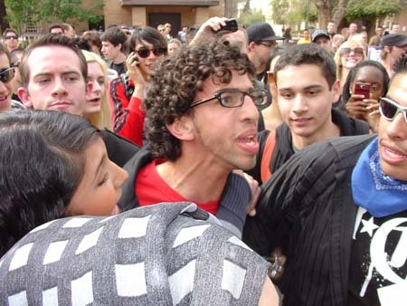
Notice one of the Girls is Holding Him Back

Martha Stands By Brother Jed to Keep the Crowd Away
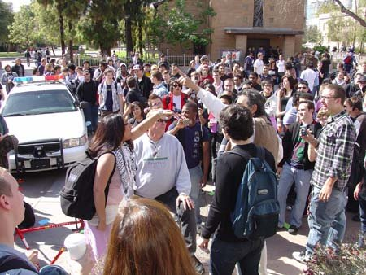
Police Car Drives Through Our Crowd in Hopes of
Dispersing the Angry Mob
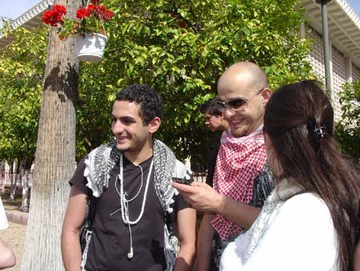
Two of the Guys Who Had Wrapped Their Heads and
Approached Brother Jed From Behind
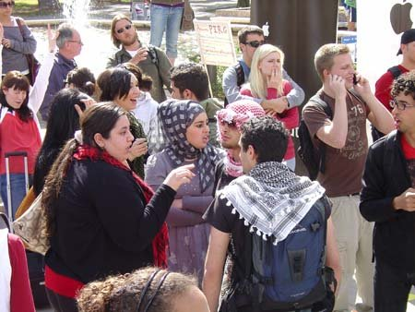
Angry Group of Muslims Plot Against Us...Looks Like an Unknown Christian is Praying For Us in The Back Left

John G. and his wife Dr. Nan were about 20 feet from me preaching to a smaller group of students. A police car kept driving through the mob to divide the horde. The police did not get out of the car. Eventually, I walked down where John and Dr. Nan were preaching and let them take over since often a change of speakers can have a calming effect. This tactic worked and several students, who really wanted to hear what I had to say, surrounded me. After about 30 minutes a 100 students started chanting for my return, “Brother Jed, Brother Jed, Brother Jed.” I resisted their call for several chants and finally relented and took my stand. I further pacified the crowd by telling a few of my stories that never seem to grow old with the students. I also told my testimony to an attentive crowd.
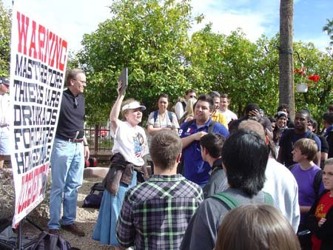
Bro. John and Dr. Nan

Shortly after 5 I dismissed the students because I had promised to have dinner with two boys who had emailed me last night. Instead, we decided to sit on the patio of the Memorial Union. These two wanted to tell me how I should preach and witness. I quickly rebuked them and said, “I will be happy to explain to you my methods and message. But I am not going to sit here and have two youths, who have never read the Bible through or never preached, tell me how to preach. I have been preaching for almost twice as long as you boys have lived.” That affected an attitude change on their part. So we had a productive 30 minutes. Meanwhile, Robert P., who heard me on campus in the early 80’s and was challenged to read the Bible, came to my defense before these boys.

Tomorrow I am returning. Please pray. These Muslim men are treacherous and harbor murder in their hearts. Enraged Muslim women were in my face for over an hour. They do not have a meek and quiet spirit like Christian women. They have an aggressive and boisterous spirit. They too are deceitful and dangerous. To the Muslims’ credit there were a few in the crowd who were trying to calm the madmen. I do not believe for a minute it was out of concern for me, but out of a concern that the Muslims could get in trouble for attacking me or make the Muslim community look bad in public. Cindy and the girls left for Missouri late this afternoon. John and Dr. Nan have to work tomorrow. As of now I have no one committed to watching my back. I will be standing alone. Yet I am not alone.

When the King of Syria was warring against the King of Israel, whom Elijah was advising, the Syrian King sent his armies to capture Elisha in Dothan. “And when the servant of the man of God was risen early, and gone forth, behold, an host compassed the city both with horses and chariots. And his servant said unto him, Alas, my master! how shall we do? And he answered, Fear not: for they that be with us are more than they that be with them. And Elisha prayed, and said, LORD, I pray thee, open his eyes, that he may see. And the LORD opened the eyes of the young man; and he saw: and, behold, the mountain was full of horses and chariots of fire round about Elisha. And when they came down to him, Elisha prayed unto the LORD, and said, Smite this people, I pray thee, with blindness. And he smote them with blindness according to the word of Elisha (2 Kings 6:15-18).”

In actuality there are more that are with me than that are with the Muslims. Frankly, I enjoy it when I am one man against a thousand. I am relying on my faithful prayer warriors to watch and pray that the Lord’s Angels will protect me from the Jihadists and their sympathizers. For those who know how to pray imprecatory prayers, as did Elisha, now is the time.
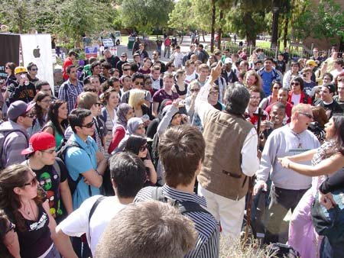
Brother Jed With Mark (blond with sun glasses)Protecting Him on the Right and Angry Iranian Girl on the Far Right

Students will kiss up to the enemies of God and our country. I appear to be one man on a dangerous mission, but I have many allies upon whom I depend.

The lewd, vulgar, ugly and unruly lesbian, who exposed herself yesterday, was holding a “hug an evil lesbian” sign for much of the afternoon. This he-girl, who spoke of love all afternoon, doused me with a bottle of water. A number of professing Christians embraced her and spoke words of love to the wretch. She passionately kissed another girl. When the boys came up to hug her I mockingly challenged them to give her a big kiss suggesting that perhaps they could awakened down deep within her poor soul a desire for men. None of the males took me up my dare. I can’t say I blame them.

A brother from a local church in which I preached this past Sunday, Donald S. came out to campus. He is a product of the Maranatha Campus Church of the 80’s. He said that he had not witnessed for a long time. He prayed that the Holy Spirit would guide him to a hungry soul. The first person he approached turned out to be open to his words of salvation. And after a long witness the man thanked Donald for speaking the Truth to him. I noticed that he witnessed to many students. He was so active that he was unaware of the commotion from the Muslim fanatics. When he left the campus the Holy Spirit informed him that he was a recipient of “the pleasure of the Lord.” In a phone conversation this evening Donald with much emotion in his voice thanked me for caring enough to bring the Gospel to campus. He testified at a men’s prayer meeting tonight about our campus ministry and several of the men expressed an interest in getting active and meeting him and me on campus Friday.

WHAT PROBLEM OF EVIL?

Arizona State University, February 25, 2010

Cindy sent out a prayer alert last night for divine protection against the mad Moslems. Two brothers showed up today to watch my back. Thomas, a retired school maintenance man, has been out every day this week. Mark, John G’s brother, who worked to keep peace yesterday, also returned.

Except for a few Moslem women occasionally listening in the crowd, the Moslems were not around today. The Iranian female who was in my face much of the time yesterday talked to Mark for a while. But she did not get close to me.

The crowd ranged from 50-100 for most of the day. At times there were heavy distractions. The big and boisterous lesbian, Diana, held forth much of the afternoon standing on the wall beside me. One base fellow was in my face for an hour shouting slogans like, “Obama is president, ha, ha, ha. You lost, we won.” He was constantly accusing me of being a hater. These types are usually homosexuals.

After five I sat on my chair just waiting for students to ask questions. Even though I was not saying much students lingered around me. Finally, a fellow in Bermuda shorts, who claimed to be an evangelist, accused me of self righteousness. He was stuck in the ditch of 1 John 1:8. I explained this verse to him in context, but he refused to receive my explanation. I tried to put him out of his rut into 1 John 3. But he loved his ditch.

At 6 PM I was a classroom speaker for the Secular Free Thought Society along with David Wendt, professor of philosophy at a local community college. In my first fifteen minute session I addressed the so called problem of evil. Atheists and others usually state the problem of evil in the form of a dilemma:
1. If God is perfectly loving, He must wish to abolish evil
2. If He is all powerful, He must be able to abolish evil
3. But evil exists
-- The problem is, if you affirm two of these facts, you cannot affirm the third.
4. Therefore, an all powerful, loving God does not exist.
I answered that this syllogism is a problem for atheists but not Christians with sound theology. Atheists have no basis for declaring anything as evil because without God there is no ultimate standard of right and wrong.
Also when God imparted free will (the power of contrary choice) to man, he limited his power. If God took away man’s freedom to do evil, man would lack the ability to be good, virtuous and loving. And man would no longer be in the image of God. Freedom of the will is necessary for there to be good and evil. God cannot take away freedom without removing the image of God in man. Perfect love will not allow God to resort to sheer force to accomplish his wishes or will. The syllogism is only problematic to those who do not understand the nature of love and the nature of freedom.
In my second fifteen minute session I expounded on God’s plan for conquering evil by changing men’s hearts through a demonstration of his love through the atonement of Christ and by the divine influence of grace. Ultimately, evildoers will be confided forever to the domain of the damned in Hell, where they will be “an abhorring unto all flesh” and an everlasting testimony to the Justice of God (Isa 66:24).
There were many issues which we covered in the interchange with Professor Wendt including original sin, election, age of accountability, Satan and the nature and character of God. He was not arguing for atheism, but what he repeatedly referred to as historical Christianity which to him was the Augustine/Calvin paradigm.
The first two hours were good. However, Diana, the lesbian, asked a question concerning homosexuality, after which the conversation degenerated; defenders lose all sense of rationality in defending the indefensible.
THE FOOL ON THE HILL
Arizona State University, February 26, 2010
Friday afternoon is pretty slow at ASU. I hadn’t been preaching for ten minutes when two street preachers from Mill Avenue, which runs parallel to campus and where students carouse at night, confronted me. They complained that my preaching simply resulted in a week long carnival. They accused me of heresy for not believing in original sin or eternal security and for believing in “sinless perfection.” I countered that I believed in Christian perfection and cited such verses as Matthew 5:48, 2 Timothy 3:16-17 and Hebrews 10:14. Predictably, they responded with 1 John 1:8. I put the verse in its immediate context and unlike most Christians, he could quote the context. But I also quoted 1 John 3:8. He appealed to the Greek and claimed that the original Greek made these verses say something other than is translated in the KJV.
I said, “You are no Greek scholar.” So he appealed to John MacArthur. In my experience when Christians are losing a Biblical argument they appeal to the Greek or to popular scholars.
Meanwhile, Thomas, who had been listening and watching my back all week, boldly accused these preachers of being hypocrites like the Pharisees. He challenged them to find a spot and proclaim their sin excusing message to the lost students instead of opposing the preacher of righteousness. I was encouraged to hear Thomas speak out for the first time. Next, Donald S., from Evident Life Church where I testified last Sunday, interrupted and engaged these two street preachers in dialogue. I do not know what he said to them, but they did not confront me anymore.
I soon gathered a crowd of about 25-35, which remained constant for the next three hours. Meanwhile, other Mill Avenue preachers, whom I had met last year on this campus, arrived. They quizzed me on original sin and the difference between justification and sanctification. They did not have a bad attitude and seemed genuinely interested in learning from where I was coming. They recorded my answers. One of them asked if he could speak. He had made a fake joint about 3 feet long and 3 inches in diameter which he used as a prop for telling the story of his conversion. He did well and had a good spirit.
At 2 PM Pastor Eric from Evident Life Church and three of his men arrived. Eric along with Donald witnessed to students. The other two listened. At 3:30 the Mill Avenue preachers interrupted my audience to respond to Diana, the lesbian. I did not mind too much since after a week of clashing with the pervert, I was glad to let someone else handle her and the whole issue of sodomy.
I had a conversation with a T.A., who taught English and specialized in John Milton. I explained that the Bible was the chief influence on Milton. Earlier in front of the crowd he had said that he considered the Bible boring and poorly written. To think that people like him are not unusual in English Departments these days! Ah, the arrogance of men that they sit in judgment on the Bible, when they have not written anything that hardly anyone would read except for a few academics. I encouraged him to keep studying Milton, who could show him the way of salvation. I left campus at 4 PM with Donald still witnessing to a small group and other pockets of conversation going on as a result of my preaching. One of the Mill Street preachers was preaching off at a distance mostly to the wind and birds. Alas, sometimes we all have to do that if we are going to be faithful to the commission to take Christ to “the highways and hedges.”
Pastor Eric told me that next year he wants to bring a team out to campus. In the evening I went to a prayer meeting of the church and Donald told me that I had “awakened a spirit of evangelism among the men.” This was a result of a ten minute testimony, Donald’s reports and Eric and his men that came to campus today.
Let me respond to the charge that I provoke a carnival atmosphere with my confrontational style. This is often the case. However, if one will read the context of the preaching of the prophets of old, the Acts of the Apostles and even Jesus this was often the case with them. When Jesus spoke to the multitudes on the plain, he said, “Woe unto you that laugh now! For ye shall mourn and weep (Luke 6:25).” It is very likely that he was responding to those who were actually mocking him during this teaching. The most sacred solemn moment in human history is Jesus hanging on the Cross. But at the foot of the hill, it was very much of a circus atmosphere with men mocking and cursing and spitting. Paul warned, “The preaching of the cross is to them that perish foolishness; but unto us which are saved it is the power of God (1 Cor 1:18).”
Whenever I preach to the world, I am regarded as the fool on the hill justly receiving ridicule and rejection. Even those that name the name of Christ or even that preach in his name will often attempt to discredit me more than the heathen will. Pilate knew that for envy the chief priest had delivered Jesus (Mark 15:10). And sadly for envy preachers will oppose other preachers, who have a larger audience than they or are having a greater impact. And the beat goes on!
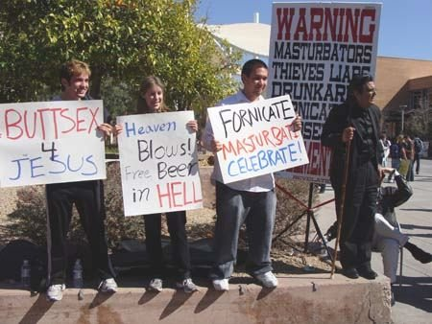
Fools Make A Mock At Sin
s

